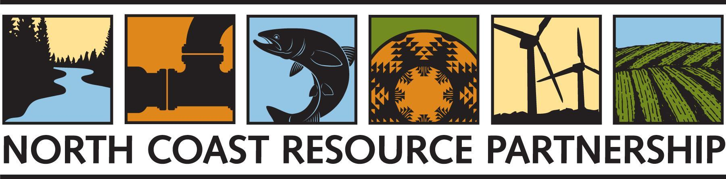

REQUEST FOR QUALIFICATIONS FOR THE

NORTH COAST RESOURCE PARTNERSHIP

On Call Consultant Services

DUE DATE: December 15, 2022

BACKGROUND
The North Coast Resource Partnership (NCRP) is an innovative, stakeholder-driven collaboration among local governments, Tribes, watershed groups, and other interested partners focused on integrated resource planning and local project implementation in California’s North Coast region. Since 2005, the NCRP has successfully integrated Tribal, federal, state, regional and local priorities and utilized a multi-benefit approach to identify and seek funding for the highest priority projects throughout the region. The focus of the NCRP includes forest and watershed health, salmonid recovery, water quality and supply, intra-regional cooperation, energy independence, climate change mitigation and adaptation, public health and economic vitality, with a specific emphasis on projects that benefit economically disadvantaged communities. The partnership is led by a Leadership Council comprised of elected officials from Tribes and counties, relies on scientific and technical review from NCRP staff and a Technical Peer Review Committee, and is informed by a broad and diverse stakeholder community. For more information about the NCRP please see the NCRP website.
The NCRP develops regional datasets, regional assessments, regional plans, identifies and prioritizes projects, advocates for regional funding, coordinates regional funding and supports local project partners and project sponsors with technical assistance, grants and other resources. The NCRP planning framework integrates the priorities of Tribal, federal, state and local partners, using regional planning to develop a shared vision for the North Coast while recognizing that “one size does not fit all” – relying upon and respecting local expertise, autonomy, jurisdictions, and planning processes.
The NCRP is issuing this Request for Qualifications (RFQ) to identify consultants to provide an array of technical services for the North Coast Region, including content and review for North Coast planning documents, research, data development, spatial analysis and mapping, project identification, development, evaluation and enhancement, regulatory and permitting assistance, as well as technical support for project sponsors.
Subcontractors that have submitted Qualifications packets in the past few years and are currently on the Approved NCRP Consultant & Technical Service Providers list, do not need to resubmit.

REQUEST FOR QUALIFICATIONS: CONSULTANT SERVICES
The NCRP seeks consultants with demonstrated experience in the following areas:

Wildfire Resilience, Forest Health and Forest Stewardship Consultant Services
The NCRP has immediate needs for consultants with demonstrated knowledge and experience related to North Coast Forest ecology and management, fuel load reduction, indigenous use of fire and forest stewardship, forest project planning and permitting issues, funding applications and grant proposal development for wildfire projects, technical research, writing, and experience in providing technical assistance to local projects sponsors. The following areas of experience are priorities in the next two years:
- In depth knowledge of forest health and forest ecosystems in the North Coast region, including their role in carbon sequestration, climate adaptation, maintaining biological diversity and culturally-significant natural and historic values, human health and safety, sustaining local economies, and water quality and supply.
- In depth knowledge of wildfire risks, hazards, and ignition sources as well as an understanding of fuel loading, fire behavior characteristics, and fire management and wildfire response.
- Experience working with California Tribes, a deep understanding of Tribal practices, and the ability to work with a variety of North Coast Tribes, and the NCRP Tribal Engagement Director
- Understanding and experience with Tribal management of wildlands and Tribal use of fire, including the practical application of Traditional Ecological Knowledge (TEK) in relationship to restoring and protecting fire resilient landscapes and cultural values.
- Knowledge and demonstrated experience in identifying shared values and priorities among diverse partnerships using processes that balance wildfire risks and hazards with community, economic, cultural, and natural values and assets.
- Knowledge and demonstrated experience in the identification, prioritization, and design of forest management techniques to establish healthy and resilient forests and achieve other benefits; using methods such as prescribed fire, cultural burning, forest thinning and sustainable timber harvest, grazing, and habitat restoration.
- Knowledge of and work experience in the landscape and human communities of the North Coast region.
- Demonstrated experience with mapping, modeling, data development and assessments related to wildfire and forest health
- Providing administrative, coordination and management services or assistance to a fire service provider, agency, district or entity
- Knowledge of and work experience in permitting and regulatory streamlining, including related policy enhancements
- Knowledge of forest economics, forest policy, funding and legislative strategies
- Knowledge and experience in regional socio-economic assessment and strategies
- Market based innovations, public-private partnerships, innovative funding approaches
- Knowledge of and demonstrated experience with forest thinning, prescribed fire, and biomass processing, biochar production and use, including the associated maintenance of existing and acquisition of new equipment and infrastructure.
- Workforce development and crew training related to wildfire and forest health
- Technical support for project proponents in the NCRP region working on wildfire and forest resilience
- Human health and safety policies - fire resiliency at the Wildland-Urban Interface: code enforcement, home hardening, community education, emergency preparedness, incentive programs
- Innovations in forest practices, equipment, tools and forest products, including knowledge of biomass utilization techniques and emerging industry trends
- Research and technical writing related to the above technical categories

Miscellaneous Consultant Services - North Coast Resource Partnership
The NCRP has immediate and longer term needs for consultants with demonstrated knowledge and experience related to North Coast ecosystems, built infrastructure (water, wastewater, energy, communications), land conservation, biodiversity protection and habitat restoration, spatial analysis and mapping, project planning and permitting, strategic planning, funding applications and grant proposal development, technical research, writing, and experience in providing technical assistance to local projects sponsors. The following areas of experience are priorities in the next two years.
- Knowledge of and work experience in the landscape and human communities of the North Coast region.
- Demonstrated experience with mapping, modeling, data development and assessments related to community and watershed resilience, supporting the goals and objectives of the NCRP
- Knowledge of and work experience in permitting and regulatory streamlining, including related policy enhancements
- Knowledge of economics, policy, funding and legislative strategies related to NCRP goals and objectives
- Knowledge of and experience related to drinking water, groundwater, surface water quality and supply
- Knowledge and experience in regional socio-economic assessment
- Knowledge and experience with California land use policies and general plan processes
- Experience with workforce development, capacity enhancement, organizational development
- Market based innovations, public-private partnerships, innovative funding approaches
- Research, technical writing
- Graphic design, story maps, web development
- Education, interpretive outreach
- Experience with habitat restoration planning and implementation
- Experience in climate science and climate modeling
- Focused surveys for endangered species and/or nesting birds
- Botanical surveys and vegetation mapping
- Cultural Surveys
- CEQA, NEPA compliance & Planning: documents and technical studies, including VTP, NOE, and MND B. Cooperative Forest Management Plans

SPECIFIC PROPOSAL REQUIREMENTS
- Cover Page (Exhibit A)
- Consultant Statement of Qualifications (maximum 3 pages), including:
  - qualifications of key personnel and proposed sub-contractors
  - hourly rates for key personnel and sub-contractors
  - 3-5 references with contact information
  - Articulate which technical services the consultant is proposing to provide to NCRP, and demonstrated experience with providing those technical services
  - list and/or hyperlinks to examples of consultant’s relevant work that support the proposal
  - confirmation of availability through June 2022, and the ability to support local project sponsors on an as-needed basis, often with a quick turnaround.

SELECTION PROCESS AND CONTRACT AWARD
Proposals will be evaluated and ranked based on a selection process using the specific criteria listed under “Proposal Evaluation”, below. Proposals for consultants providing services to Tribes will be reviewed by the Tribal members of both the NCRP Leadership Council and the Technical Peer Review Committee. Entities selected specifically to provide Tribal consultant services will enter into a contract and work closely with the NCRP Tribal Engagement Director, California Indian Environmental Alliance (CEIA) and NCRP Tribal Representatives. All other consultants will enter into a contract and work closely with NCRP Staff, West Coast Watershed (WCW).
The NCRP expects to issue contracts to consultants within the selected pool over a two-year period, although selection for the pool does not guarantee a contract. During this two year period, the NCRP anticipates issuing several small and medium sized open scope contracts to consultants, ranging from $5,000-$50,000. It is expected that each technical consultant will demonstrate the ability to actively work with NCRP staff and other selected technical consultants to collaboratively develop work products and integrated, multi-benefit strategies for the North Coast region. WCW & CIEA reserve the right to select all or part of a consultant’s offered technical services portfolio and to request consultants to combine with other consultants into an integrated team. Subsequent requests for qualifications/proposals may be announced if needed.
The selected consultant(s) or team will be asked to submit a detailed scope of work, schedule, and cost proposal, after further discussions with WCW & CIEA regarding roles and responsibilities, tasks, and work products. The scope of work, schedule, and budget will be incorporated into the WCW or CIEA’s standard Agreement for Professional Services.

EVALUATION CRITERIA
The following criteria will be used by the NCRP in evaluating submissions:
- Experience and demonstrated competence in the identified areas of service outlined in this RFQ
- Thoroughness, quality and responsiveness of submission
- Quality and relevance of references
- Comprehensive and reasonable consultant fee schedule
- Local preference (consultant located in the North Coast Region)

Insurance Requirements
- Comprehensive or Commercial General Liability Insurance at least as broad as Insurance Services Office Commercial General Liability Coverage (occurrence form CG 0001), in an amount of Two Million Dollars ($2,000,000) per occurrence for any one incident, including, but not limited to, personal injury, death and property damage. If a general aggregate limit is used, such limit shall apply separately hereto or shall be twice the required occurrence limit.
- Automobile/Motor Liability Insurance with a limit of liability not less than One Million Dollars ($1,000,000) combined single limit coverage. Such insurance shall include coverage of all owned, hired and non-owned vehicles. Said coverage shall be at least as broad as Insurance Service Office Form Code 1 (any auto).
- Workers’ Compensation Insurance, as required by the Labor Code of the State of California, with statutory limits, and Employers Liability Insurance with a limit of no less than One Million Dollars ($1,000,000) per accident for bodily injury or disease. Said policy shall contain, or be endorsed to contain, a waiver of subrogation against West Coast Watershed and/or California Indian Environmental Alliance, the County of Humboldt, its agents, officers, officials, employees and volunteers.
Please note, if the project does not involve travel and/or the project sponsor does not have employees, insurance requirements may be altered at the discretion of Humboldt County Risk Management.

PROPOSAL SUBMITTAL

Proposal Packet
All proposals will include a Proposal Cover Page (Exhibit A, below) along with Specific Proposal Requirements. Subcontractors that have submitted Qualifications packets in the past few years and are currently on the Approved NCRP Consultant & Technical Service Providers list do not need to resubmit.

Delivery of Proposals
Proposals should be emailed to Karen Gaffney kgaffney@northcoastresourcepartnership.org
The deadline for submission of proposals is 5:00 p.m. on December 15, 2022.

Inquiries
Questions may be directed to Karen Gaffney kgaffney@northcoastresourcepartnership.org or 707.583.6757.

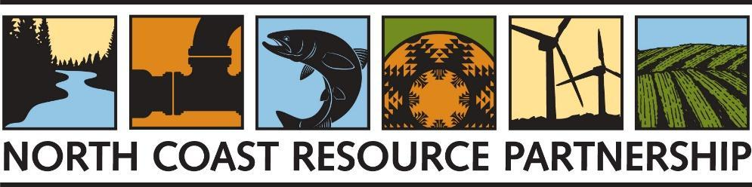

EXHIBIT A

COVER PAGE

Proposal Type
Please select all the proposal types submitted.
☐ Forest Health and Wildfire Tribal Consultant Services
☐ Forest Health and Wildfire Consultant Services
☐ Miscellaneous NCRP Tribal Consultant Services
☐ Miscellaneous NCRP Consultant Services

Organization Name

_________________________________________________________________________

Organization Type
☐ Federally recognized Indian Tribe
☐ California State Indian Tribe
☐ Indian Tribe or Tribal Group
☐ Public agency
☐ Local or state agency/special district
☐ Resource Conservation District
☐ Non-profit organization
☐ Public utility
☐ Consulting firm
☐ Other (describe): ________________________________________________________________

Contact Name/Title

Name: __________________________________________________________

Title: __________________________________________________________

Email: __________________________________________________________

Phone Number (include area code): __________________________________

Organization Address (City, County, State, Zip Code):

________________________________________________________________

Authorized Representative (if different from the Contact name)

Name: ________________________________________________________________

Title: ________________________________________________________________

Email: ________________________________________________________________

Phone Number (include area code): _________________________________________

Certification of Authority
By signing below, the person executing the certificate on behalf of the proposer affirmatively represents that s/he/they has the requisite legal authority to do so on behalf of the proposer. Both the person executing this proposal on behalf of the proposer and proposer understand that the NCRP is relying on this representation in receiving and considering this proposal. The person signing below hereby acknowledges that s/he/they has read the entire Request for Qualifications document and has complied with all requirements listed therein.

Official Authorized to Sign for Proposal

______________________________________________________________
Signature

__________________________________________
Date

