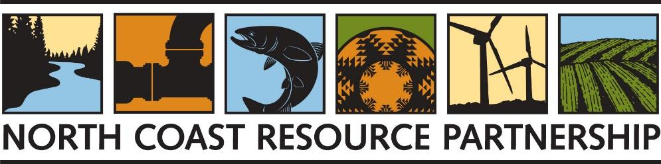

APPLICATION FOR PROJECT DEVELOPMENT TECHNICAL ASSISTANCE

EXHIBIT A

PROPOSAL COVER PAGE

Project Name

Click or tap here to enter text.
Organization Name

Click or tap here to enter text.

Organization Type
☐ Federally recognized Tribe
☐ California State Indian Tribe
☐ Public agency
☐ Local or state agency/special district
☐ Resource Conservation District
☐ Non-profit organization
☐ Public utility
☐ City or Town
☐ Other: Click or tap here to enter text.

Organization Economically Disadvantaged Community Status
☐ Tribal Community
☐ Economically Disadvantaged Community
☐ Severely Disadvantaged Community

Contact Name/Title

Name: Click or tap here to enter text.

Title: Click or tap here to enter text.

Email: Click or tap here to enter text.

Phone Number (include area code): Click or tap here to enter text.

Organization Address (City, County, State, Zip Code):
Click or tap here to enter text.

Authorized Representative (if different from the contact’s name)

Name: Click or tap here to enter text.

Title: Click or tap here to enter text.

Email: Click or tap here to enter text.

Phone Number (include area code): Click or tap here to enter text.

Certification of Authority
By signing below, the person executing the certificate on behalf of the proposer affirmatively represents that s/he has the requisite legal authority to do so on behalf of the proposer. Both the person executing this proposal on behalf of the proposer and proposer understand that the NCRP is relying on this representation in receiving and considering this proposal. The person signing below hereby acknowledges that s/he has read the entire Request for Proposals document and has complied with all requirements listed therein.

Official Authorized to Sign for Proposal

Signature

Click or tap to enter a date.
Date

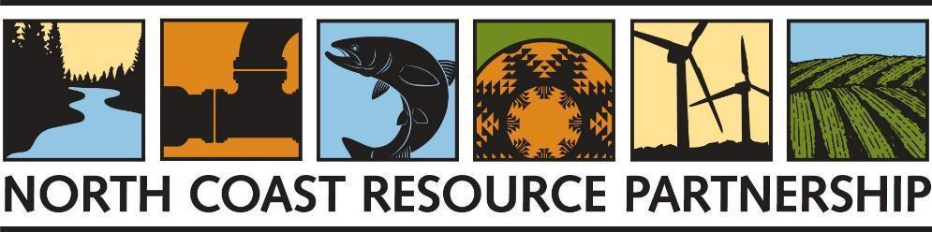

EXHIBIT B
CONCEPT PROPOSAL TEMPLATE
Please complete a Concept Proposal for Project Development and Technical Assistance (maximum 5 pages) that demonstrates an understanding of the NCRP and funding partner goals and objectives, describes potential project activities that promote one or several of the following: forest/ watershed health, fuel load reduction, salmonid recovery, intra-regional cooperation, climate change mitigation/ adaptation, water quality/ supply, public health and economic vitality. The concept proposal must also demonstrate a clear need for Technical Assistance to develop the proposed project.

Project Name: Click or tap here to enter text.

- Abstract of the project for which you are requesting technical assistance [750 characters max.]
Click or tap here to enter text.
- Detailed description of the project for which you are requesting technical assistance [2000 characters max.]
The Project Description should include: the intended purpose of the project; a problem statement: why the project or process is needed; setting and background; the major components of the project or process; a description of how the project or process will be implemented (if known) and a summary of the expected/desired benefits.
Click or tap here to enter text.

- List and describe specific Project Goals/Objectives
Click or tap here to enter text.
- Describe the specific technical assistance needed to fully develop the project and why technical assistance is requested from your organization.
Click or tap here to enter text.
- Describe how the project addresses the NCRP Goals and Objectives
Click or tap here to enter text.
- Briefly describe the location and size of the project.
Click or tap here to enter text.
- Describe how the project provides direct benefits to a project area comprised of Tribes, Economically Disadvantaged Communities or Severely Disadvantaged Communities and list these communities. [NCRP Interactive Map]
Click or tap here to enter text.
- Describe how the project addresses the need of the communities listed above.
Click or tap here to enter text.
- List and describe the partnerships involved in the project and local and/or political support.
Click or tap here to enter text.
- List the estimated benefits expected to result from the proposed project.
Click or tap here to enter text.
- List any existing scientific studies, plans, designs or engineering reports related to the project for which you are requesting technical assistance project.
Click or tap here to enter text.
- List the approximate project cost and potential sources of grant and matching funds, including amounts and their status.
Click or tap here to enter text.

- List any upcoming Tribal, state, federal, philanthropic funding programs (IRWM, CAL FIRE, other) for which you intend to submit an implementation funding application.
Click or tap here to enter text.

EXHIBIT C

ORGANIZATION STATEMENT OF QUALIFICATIONS

Please complete a statement of qualifications that briefly describes the organization’s key personnel and their qualifications and list/hyperlinks to examples of relevant work that support the proposal
Statement of Qualifications
Click or tap here to enter text.

