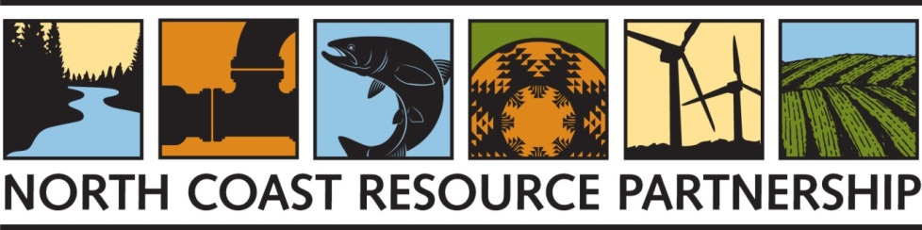

IMPLEMENTATION PROJECT SPONSOR SURVEY: GRANT APPLICATION PROCESS AND CONTRACT ADMINISTRATION

WE WOULD LOVE TO HEAR FROM YOU!
You are receiving this survey because you have been identified as a representative of an agency or organization that has received funding in the past or is currently administering a grant award through the North Coast Resource Partnership (NCRP) Integrated Regional Water Management (IRWM) program. Programmatic evaluation has been taking place on an ongoing basis – with NCRP staff documenting input from stakeholders and partners. In anticipation of Proposition 1 IRWM funding, (anticipated to roll out in the fall of 2018), the NCRP would like to gather information about the project proposal solicitation process and contract administration. Given your past experience as a project sponsor, your insights are valuable and will assist the NCRP to identify barriers to participating in the next round of funding and potential solutions. The Department of Water Resources has been very interested in and receptive to input from the NCRP since the inception of the IRWM program, creating an opportunity to work in partnership with the State to enhance this program. Your feedback will inform the NCRP’s continued collaboration with DWR to continually improve the IRWM program.

BACKGROUND
The NCRP planning process has been positive for the North Coast region – providing an opportunity and an incentive for a significant and unique hydrologic region to work collaboratively and proactively on critical water management challenges, to reduce conflicts, and to identify and prioritize meaningful projects in some of the most disadvantaged communities in the state. The NCRP experience in the past twelve years supports the concept that large scale, adaptive planning – administered at the local level, informed by local knowledge and priorities, with strong communication and linkages to state agencies and priorities – is an effective means to manage water and natural resources. Please visit the NCRP website for more information (https://northcoastresourcepartnership.org/).

The NCRP places a strong emphasis on science-based planning, adaptive management and process improvement – constantly evaluating and seeking to advance its programmatic approach as new information becomes available. In addition to improving the NCRP processes, programmatic evaluation also enables the NCRP to articulate challenges with the IRWM program, positive aspects of the program, as well as a set of concrete recommendations that demonstrate responsiveness and accountability in terms of use of public funds. This survey will support the NCRP’s current programmatic evaluation and continued improvement.

SURVEY
We hope you are willing to participate in the following survey by providing responses to as many of the questions below as you are able. We are conducting the survey by multiple methods to make it easiest for respondents. The survey can be filled out and returned by email to kgledhill@westcoastwatershed.com or online at the following URL: https://www.surveymonkey.com/r/NCRP_Project_Sponsor_Survey. We are also happy to conduct the survey by telephone. Please let us know if you prefer this option and we can arrange a phone interview at a time that is convenient to you. We anticipate that the survey should take about 20 – 30 minutes to complete. PLEASE COMPLETE THE SURVEY NO LATER THAN SEPTEMBER 14TH.

NCRP Implementation Project Grant Application Process

- Do you feel the North Coast Resource Partnership (NCRP) Project Review and Selection Process has been fair, equitable, and transparent? yes no

If not, please describe how the processes could be improved.

- Can you provide us with an estimate of how much time you or your agency spent on the most recent NCRP project funding applications?
< 10 hours
10 – 20 hours
20 – 30 hours
30 – 40 hours
40 – 50 hours
> 50 hours

- Do you have any suggestions for streamlining or modifying the application that makes it more efficient while still providing the required data for a comprehensive review by the NCRP Technical Review Committee?

- In comparison to other grants you have submitted, how would you compare the NCRP grant application process?
1 = more difficult than any grant I have submitted in the last 3 years
2 = about the same as other grants I have submitted in the last 3 years
3 = simpler and more straightforward than other grants submitted in the last 3 years.

If your answer is 1, what element or elements caused this increased difficulty?

- The NCRP has developed a grant application process that aims to strike a balance between assuring the state that tax dollars are well spent, providing enough information for the TPRC to clearly understand what the benefits of the project will be, and providing an application that is not so complex that it is a deterrent to the project proponents. How successful has the NCRP been in striking that balance?
Very successful
Somewhat successful
Unsuccessful
Unsure

Do you have suggestions for improvement? Please be specific.

- What are some positive aspects of the NCRP program/application process that should be retained?

- If applicable, please comment on the degree to which the NCRP project application process enhances your project’s readiness and viability for future funding opportunities.
Greatly enhanced the readiness/viability of my project
Somewhat enhanced the readiness/viability of my project
Did not enhance the readiness/viability of my project

- Other information or suggestions you would like to share with us?

Grant Administration

- If you have been a NCRP grant recipient, did you find the grant administration process challenging?
Very challenging
Somewhat challenging
Not very challenging at all

If there were grant administration challenges, please explain, and share with us any suggestions for enhancement.

- What were the positive elements of administering the grant(s)?

- How did your organization leverage funds while awaiting payments & withheld retention?

- Do you have any feedback relating to the following components of grant administration:
  - Invoicing and Reporting

  - Payment timeframe

  - Advanced Payment

- Was the Sub-Grantee Grants Compliance Manual provided by the County of Humboldt helpful?
Very helpful
Somewhat helpful
Did not help at all
Unsure

If helpful, what were the helpful elements? If not helpful, suggestions for enhancing its helpfulness?

- Were the orientation calls facilitated by Humboldt County grant administrators helpful and informative?
Very helpful
Somewhat helpful
Did not help at all
Unsure

If helpful, what were the helpful elements? If not helpful, suggestions for enhancing its helpfulness?

- Would you apply for IRWM funds again? yes no
Why or why not?

- Is there anything else you would like to share about your grant administration experience?

General NCRP Regional Collaborative Process

- Are you satisfied with the overall NCRP process to date? Is the process sufficiently open, participatory, and accountable?
Very satisfied
Somewhat satisfied
Neither satisfied nor dissatisfied
Dissatisfied
Not familiar with the overall NCRP process

Comments or suggestions?

- Are there specific aspects of the NCRP process you would retain?

- Are there specific aspects of the NCRP process that you would modify or improve?

- Has outreach to stakeholder groups been sufficient?
Very sufficient
Somewhat sufficient
Insufficient
Not aware of NCRP outreach efforts

Are there ways you would improve the stakeholder identification/ outreach/ notification/ participation process?

- Do you feel there has been/ will be sufficient opportunity for participant input on the NCRP Plan and process?

- Are the costs for you to participate in the NCRP process prohibitive?
yes no

What is the estimated cost for you to participate in the NCRP process?

- Do you feel there has been equitable representation of your County/Tribal area in the NCRP process? yes no

If not, how would you make representation more equitable?

- Do you have recommendations for improving coordination within the North Coast region and with adjacent IRWM regions?

- Are there questions or topics that you would like the NCRP to address in workshops or presentations at quarterly meetings?

- What are your suggestions for future direction for the NCRP effort?

